RHL-TH130 Digital Metal Hardness Tester
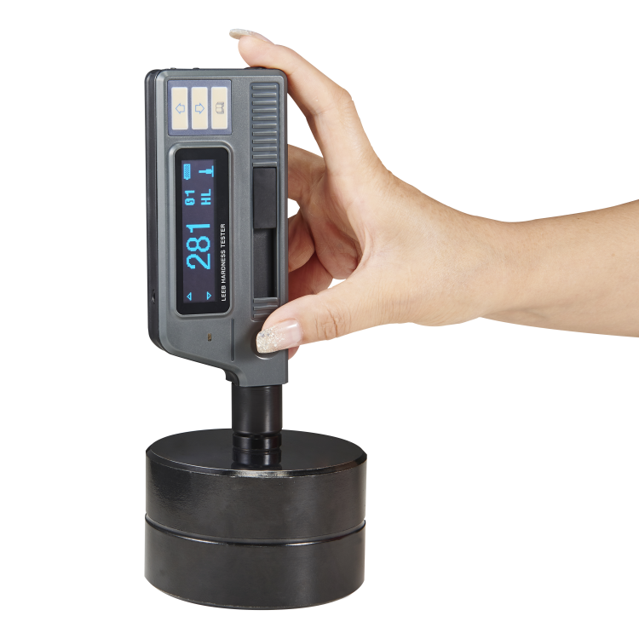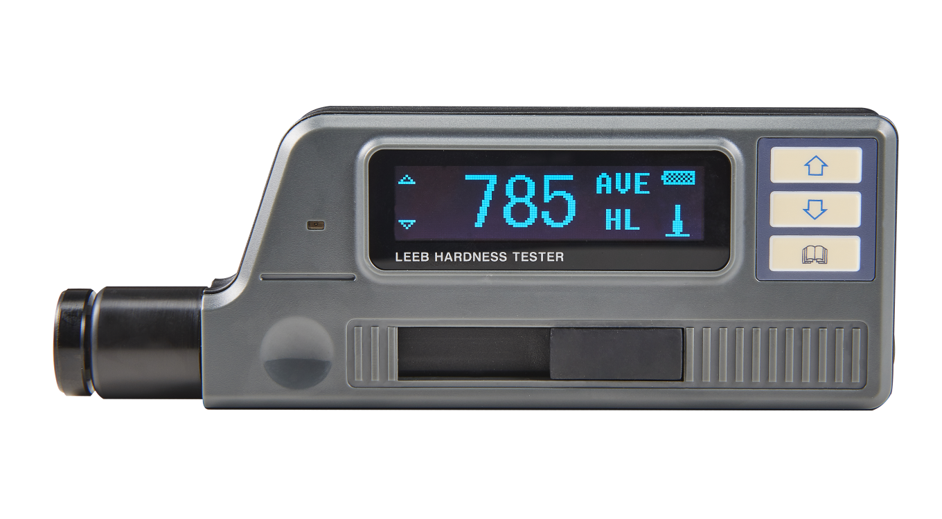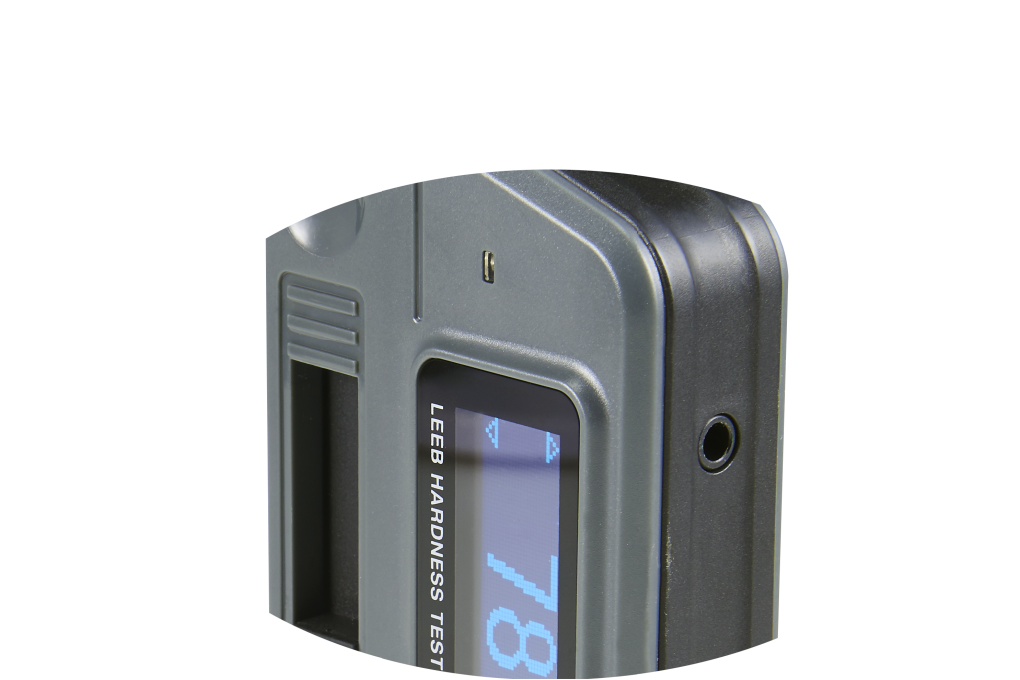

Advantages
- Large screen(128×64 dot matrix LCD), showing all functions and parameters.
- Test at any angle, even upside down.
- Wide measuring range. It can measure the hardness of all metallic materials. Direct display of hardness scales HRB, HRC, HV, HB, HS, HL and three types of strength values immediately.
- Seven impact devices are available for special application. Automatically identify the type of impact devices.
- Large capacity memory could store 1000 groups (Relative to average times32～1 ) information including single measured value, mean value, testing data, impact direction, impact times, material and hardness scale etc.
- Upper and lower limit can be preset. It will alarm automatically when the result value exceeding the limit.
- Battery information indicates the rest capacity of the battery and the charge status.
- User calibration function.
- USB port with the PC humanity multi-functions data proceeding software.
- Original imported high speed thermal printer support the immediate printing function. It can save data permanently.
- NI-MH rechargeable battery as the power source. Charge circuit integrated inside the instrument. Continuous working period of no less than 150 hours (EL off and no printing).
- Auto power off to save energy.
- Excellent after-sale service system for high quality products---two years’ guarantee and all life maintenance. Easy to buy and comfortable to use.

Main Application
- Die cavity of molds
- Bearings and other parts
- Failure analysis of pressure vessel, steam generator and other equipment
- Heavy work piece
- The installed machinery and permanently assembled parts
- Testing surface of a small hollow space
- Material identification in the warehouse of metallic materials
- Rapid testing in large range and multi-measuring areas for large-scale work piece

Technical Specifications
- Measuring range：HLD（170～960）HLD
- Measuring direction：360°
- Hardness Scale：HL、HB、HRB、HRC、HRA、HV、HS
- Display：dot matrix LCD，128×64 dots
- Data memory： 500 groups max.（relative to impact times 32～1）
- Printing paper: width is （57.5±0.5）mm, diameter is 30mm
- Battery pack: 6V NI-MH
- Battery charger: 9V/500mA
- Continuous working period：about 150 hours（With backlight off, no printing）
- Communication interface：USB1.1
- Outline dimensions：212mm×80mm×32mm

Configuration
 | No. | Item | Quantity | Remarks
Standard Configuration | 1 | Main Unit | 1
Standard Configuration | 2 | D type impact device | 1 | Without cable
Standard Configuration | 3 | Standard test block | 1
Standard Configuration | 4 | Cleaning brush (I) | 1
Standard Configuration | 5 | Small support ring | 1
Standard Configuration | 6 | Battery Charger | 1 | 9V 500mA
Standard Configuration | 7 | Paper for printing | 1
Standard Configuration | 8 | Manual | 1
Standard Configuration | 9 | DataPro software | 1
Standard Configuration | 10 | Communication cable | 1
Standard Configuration | 11 | Instrument case | 1
 | 12 | Cleaning brush (II) | 1 | For use with G type impact device
 | 13 | Other type of impact devices and support rings |  | Refer to Table 3 and Table 4 in the appendix.

